**Miami-Dade County COVID-19 Hospital Impact Model for Epidemics (CHIME)**

The following epidemiological model was created for Miami-Dade County Fire Rescue by researchers at Florida International University. The model was created using the CHIME model created at the University of Pennsylvania (1). The report details three separate scenarios for social distancing, 20%, 40% and 60 % social distancing and resultant expectation estimates.

**Model Assumptions**

As of **April 2nd, 2020** the estimated number of currently infected individuals is **17701**. This is based on current inputs for Hospitalizations (**1058**), Hospitalization rate (**2%**), Region size (**2752000**), and Hospital market share (**100%**). An initial doubling time of **2.5** days and a recovery time of **14** days. Low social distancing corresponds to **20%** reduction in social contact, moderate social distancing corresponds to a **40%** reduction in social contact, and high social distancing corresponds to a **60%** reduction in social contact.

| **Miami-Dade County COVID Hospital Expectation Estimates** | | | |
| --- | --- | --- | --- |
|  | **20 % Social Distancing** | **40% Social Distancing** | 60% Social Distancing |
| Hospital Admit Peak Date | 3,757 | 2,415 | 1,104 |
| Hospital Admit Peak Amount | Apr 24th, 2020 | May 03rd, 2020 | May 24th, 2020 |
| Total Hospital Admits by July 11th | 68,050 | 65,976 | 55,250 |
| ICU Admit Peak Date | Apr 24th, 2020 | May 03rd, 2020 | May 24th, 2020 |
| ICU Admit Peak Amount Per Day | 1,128 | 725 | 332 |
| Total ICU Admit by July 11th | 20,415 | 19,792 | 16,575 |
| Ventilated Admit Peak Date | Apr 24th, 2020 | May 03rd, 2020 | May 24th, 2020 |
| Ventilated Admit Peak Amount Per Day | 752 | 483 | 221 |
| Total Ventilated by July 11th | 13,610 | 13,195 | 11,050 |

**Scenario 1: Low Social Distancing (20%)**

**New Admissions per day**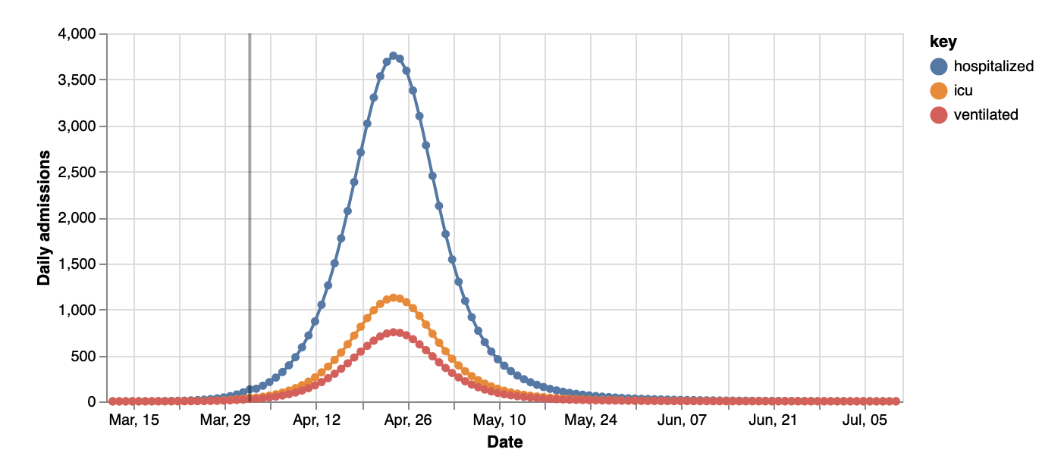

Hospitalized Admissions peaks at **3,757** on Apr 24

ICU Admissions peaksat **1,128** on Apr 24

Ventilated Admissions peaks at **752** on Apr 24

**Census (Total Burden per date)**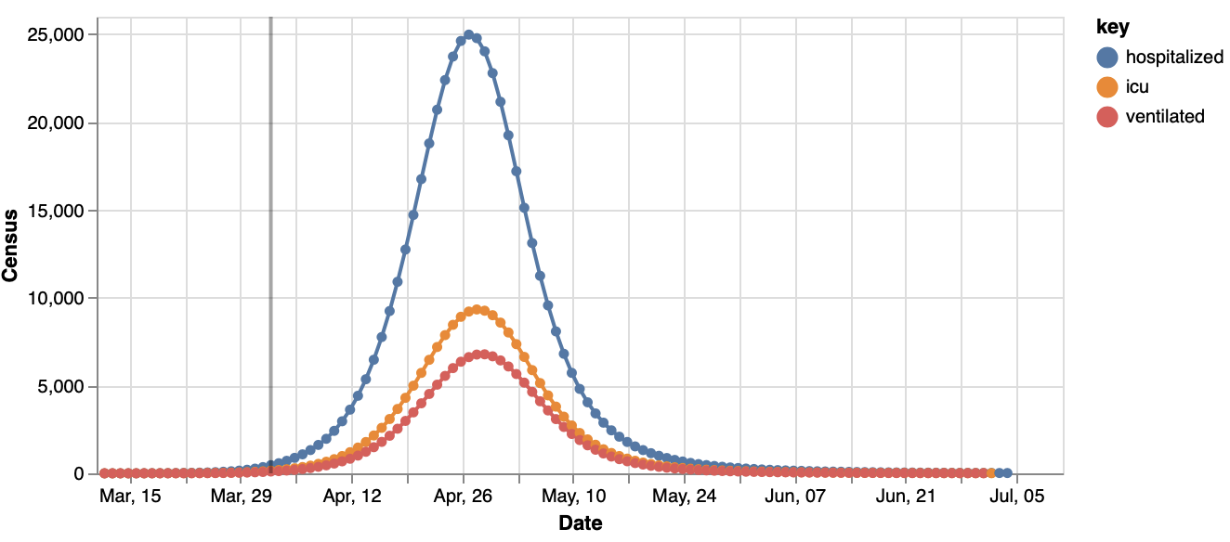

Hospitalized Census peaks at **24,980** on Apr 27

ICU Census peaks at **9,330** on Apr 28

Ventilated Census peaks at **6,777** on Apr 29

**Scenario 2: Moderate Social Distancing (40%)**

**New Admissions per day**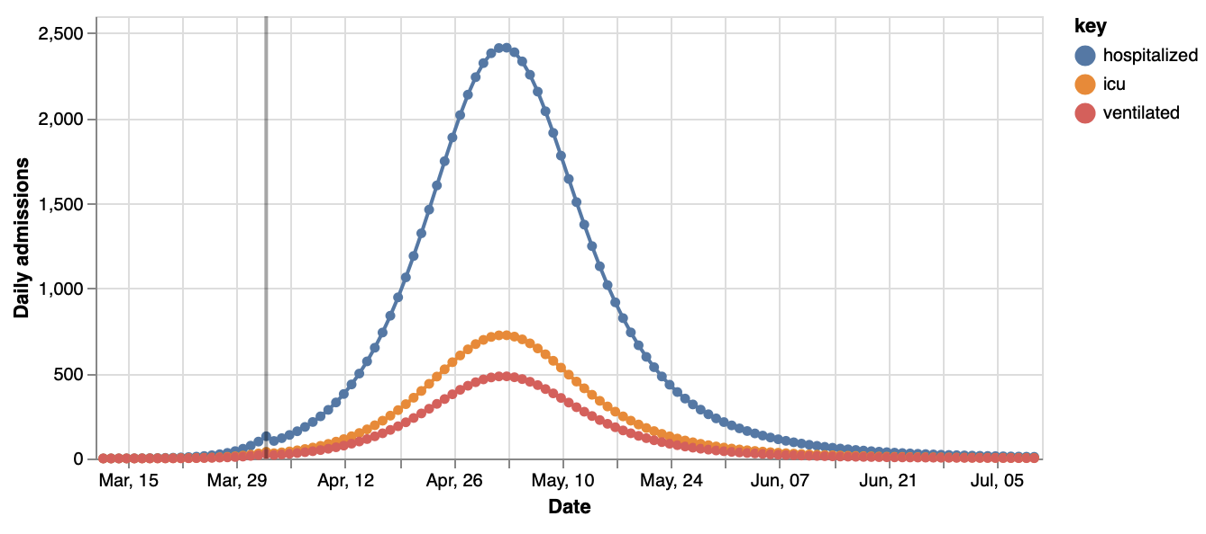

Hospitalized Admissions peaks at **2,415** on May 03

ICU Admissions peaks at **725** on May 03

Ventilated Admissions peaks at **483** on May 03

**Census (Total Burden per date)**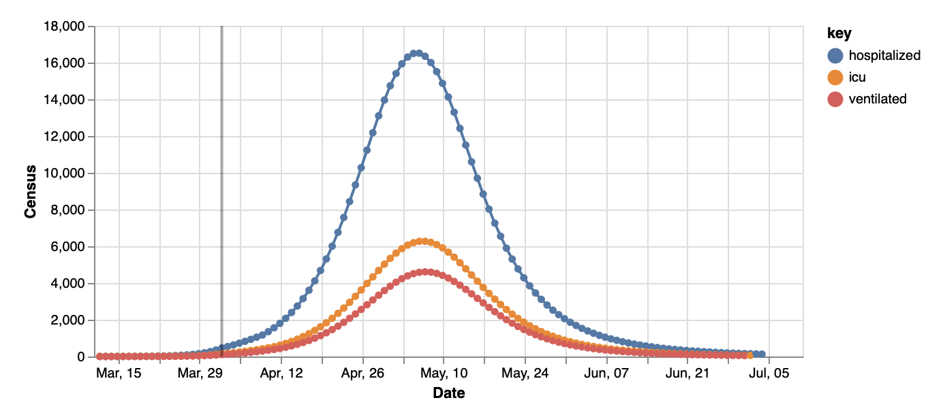

Hospitalized Census peaks at **16,512** on May 06

ICU Census peaks at **6,273** on May 07

Ventilated Census peaks at **4,610** on May 07



**Scenario 3: Large Social Distancing (60%)**

**New Admissions per day**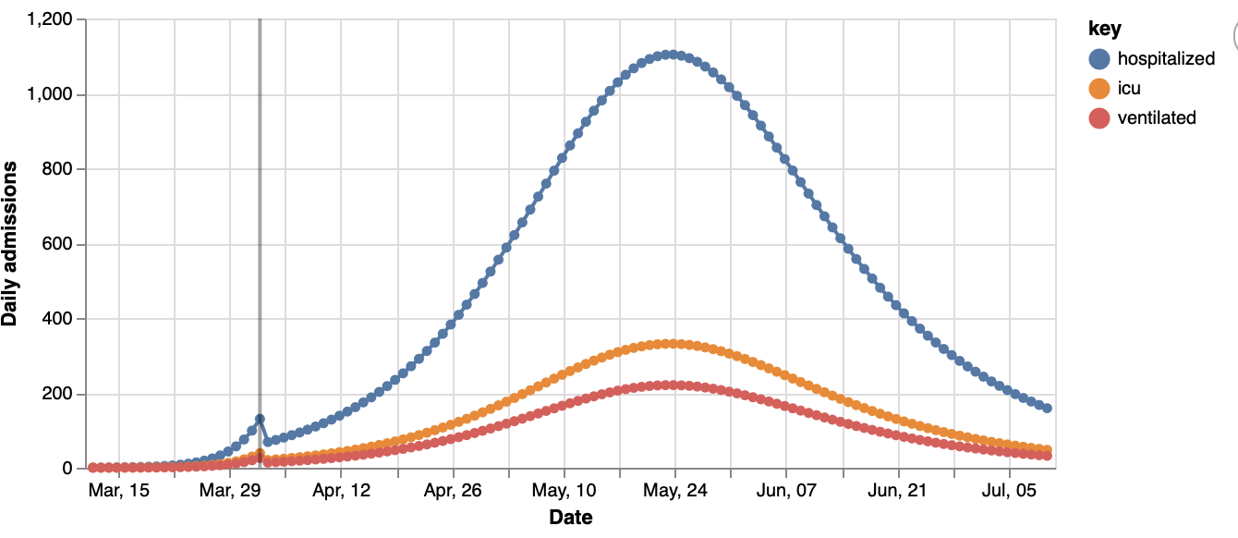

Hospitalized Admissions peaks at **1,104** on May 24

ICU Admissions peaks at **332** on May 24

Ventilated Admissions peaks at **221** on May 24

**Census (Total Burden per date)**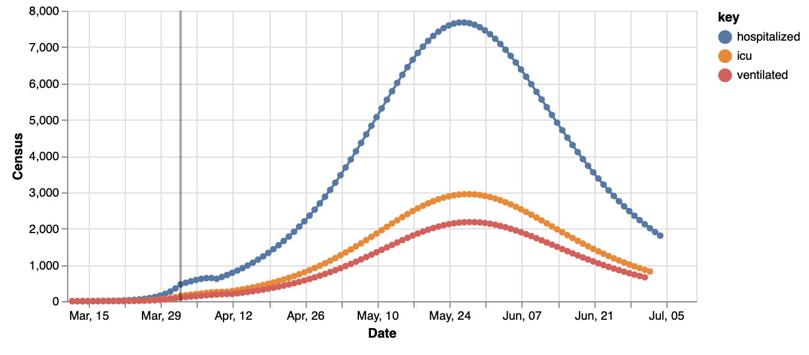

Hospitalized Census peaks at **7,677** on May 27

ICU Census peaks at **2,949** on May 28

Ventilated Census peaks at **2,180** on May 28

**Executive Summary**

To this author’s knowledge, this is the first CHIME model applied to Miami-Dade County. Based on the magnitude of social distancing, the expected total number of hospitalizations predicted by **July 11th, 2020** ranges from **55,250** to **68,050**. The peak of the epidemic in terms of daily hospitalizations, daily ICU cases, and daily ventilations varies by the amount of social distancing and ranges from **April 24th, 2020** to **May 24th 2020.** The average and baseline assumption appears to be **May 3rd** if 40% social distancing occurs. Strikingly, May 3rd corresponds exactly to the predicted peak resource usage for the State of Florida found using the Institute of Health Metrics and Evaluation’s Covid model (2). Peak Burden (census), i.e., the amount of hospitalizations occurring during the same time period ranges from **24,980 to 7,677.** Increasing social distancing from 20% social contact reduction to 60% social contract reduction reduces hospitalizations by approximately **70%**, and flattens the epidemic curve by approximately one month. For the ICU census peak, this value ranges from **9,330** to **2,949.** At 60% social contract reduction compared with 20%, this results in a **68.4%** reduction in ICU burden. Census peak for ventilation ranges from **6,777** to **2,180.** Similarly to hospitalization and ICU burden, through social distancing, peak ventilation census can be delayed by a month from April 29th to May 28th. For ventilation census, this can be reduced by **67.83%**. The reduction in peak epidemic burden is similar to the 69% reduction via social distancing found by Imperial College and the 65% census reduction found by the University of Pennsylvania (3). The next step for predicting Covid hospital impact in Miami-Dade County will be quantifying the resource availability, resource need, and total mortality for Covid-19 in Miami-Dade County, and South Florida as a whole.

**Susceptible, Infected, and Recovered (SIR) Models**

This correspond with number of susceptible, infected, and recovered individuals in the hospital catchment region at any given moment

**Scenario 1: Low Social Distancing (20%)**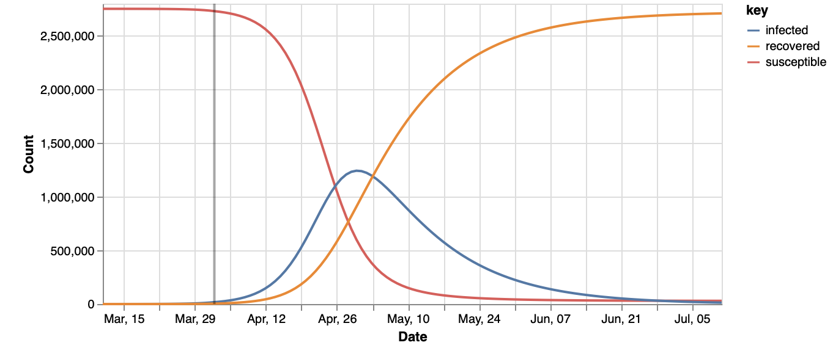

**Scenario 2: Moderate Social Distancing (40%)**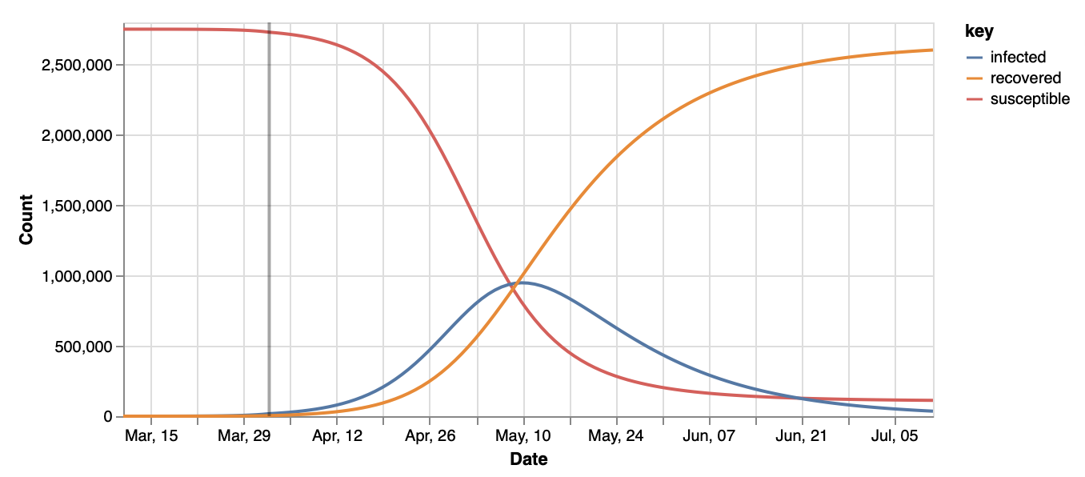

**Scenario 3: Large Social Distancing (60%)**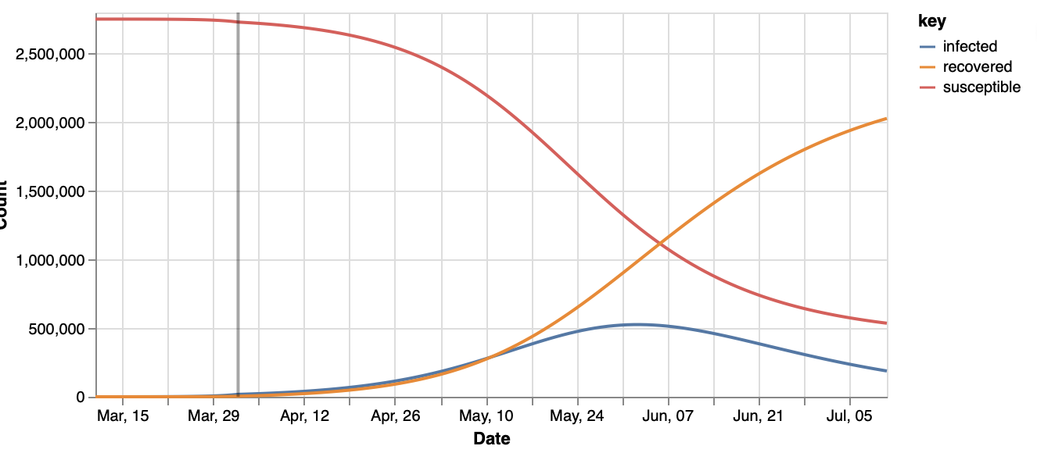

**References**

(1) University of Pennsylvania Covid Model. (2020, March 15). Retrieved April 2, 2020, from <https://code-for-philly.gitbook.io/chime/#quick-resources>

(2) IHME COVID-19 health service utilization forecasting team. Forecasting COVID-19 impact on hospital bed-days, ICU-days, ventilator days and deaths by US state in the next 4 months. MedRxiv. 26 March 2020. doi:10.1101/2020.03.27.20043752.

(3) Draugelis, M., & Hanish, A. (2020, March 18). CHIME comparison with Imperial College COVID-19 Publication. Retrieved April 2, 2020, from http://predictivehealthcare.pennmedicine.org/2020/03/18/compare-chime.html

**Appendix**

**Model Parameters**